RESOLUTION NO.__________

RE: CERTIFICATE OF APPROPRIATENESS UNDER THE
PROVISIONS OF THE ACT OF THE PENNSYLVANIA
LEGISLATURE 1961, JUNE 13, P.L. 282 (53
SECTION 8004) AND BETHLEHEM ORDINANCE NO.
3952 AS AMENDED.

The applicant proposes to replace the roof at 403 Center St.

NOW, THEREFORE, BE IT RESOLVED by the Council of the City of Bethlehem that a Certificate of Appropriateness is hereby granted for the proposal.

Sponsored by: (s)

(s)

ADOPTED BY COUNCIL THIS DAY OF

(s)
President of Council

ATTEST:

(s)
City Clerk

HISTORICAL & ARCHITECTURAL REVIEW BOARD

The applicant proposes to replace the roof at 403 Center St.

APPLICATION #9:

James/Eileen Serratelli
403 Center St.
Bethlehem, PA 18018
OWNER:

__________________________________________________________________________

The Board upon motion by Beth Starbuck and seconded by Connie Postupack adopted the proposal that City Council issue a Certificate of Appropriateness for the following:

- Replace the roof with GAF Camelot 2 Lifetime Designer Series shingle in
Antique Slate.

2. Open valleys are to be either copper or lead lined copper pans.

3. Drip edges to be either copper or aluminum in the color of any adjacent trim.

4. The ridges are shingle-over ridge vents.

5. Dormers are approved for 4” lap siding and metal roofing.

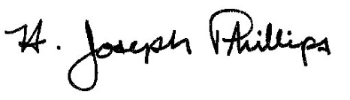 By:__H. Joseph Phillips___________

Title: __Historic Officer____________

Date of Meeting: November 7, 2018

